Compassionate Listening
Article by Dr. Paul Leavenworth

Compassionate listening can be defined as, “caring enough about another person to really hear their story.” This definition involves three components:

- COMPASSION (Attitude)
- ACTIVE LISTENING (Techniques)
- TRANSFORMATION (Outcome)

Assumptions About Compassionate Listening: I list ten assumptions that have helped me formulate my paradigm and methodology for compassionate listening:

- People are valuable
- People are complex
- People tend to be formed by their social experiences
- People need to be and desire to be loved and to love
- People need a purpose greater than themselves to invest in in order to be healthy and functional
- People can change if they are willing to take responsibility for their own growth and development
- People resist change until they are convinced that change is necessary
- People tend to be more open to change if they discover and own the necessary change themselves
- People tend to experience more rapid and significant transformation if they are involved in healthy, intentional mentor-coaching relationships
- People who can gain most from mentor-coaching tend to be relatively healthy and functional and are faithful and teachable

Based on this definition, I have developed a skill training process that involves training individual in three areas:

- Active Listening
- Discovery Learning
- The IDEA Methodology

These skills can be applied to individual mentor-coaching and facilitation of small discovery learning groups. Over time, the practice of the skills involved in compassionate listening can lead to both individual and organizational transformation.
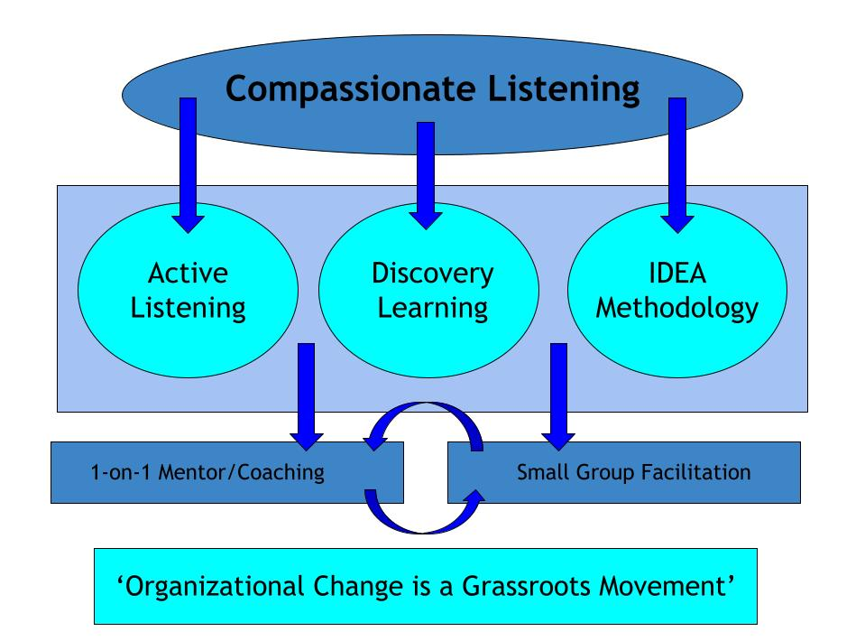

Active Listening: Generally, there are seven components involved in effective active listening that can help us listen to the “story in the story” when compassionately listening to others:

- Attending – awareness of verbal and non-verbal contents.

- Verbal and non-verbal “attending” interpretation – non-verbal “cues” are often more important than words alone.

- Asking appropriate questions – non-judgmental and open-ended questions starting with “what,” “how,” “who,” “when” tend to be most helpful. Be careful about asking “why” questions as they can tend to convey “judgment.”

- Focus or context of communication – try to listen to the “story” in the story. Usually there is a “back story” behind the current story.

- Reflecting back to the sender what you think you are hearing – use phrases like “if I understand what you are saying, I hear you saying…” or “this is what I am hearing you say…” This gives them an opportunity to clarify what they are really saying.

- Summarization – repeat back to them what you hear them saying which gives them an opportunity to agree or disagree. This technique reinforces that you care and really are trying to “hear” them.

- Next steps – helping them formulate an action plan and taking the next step in “eating the elephant one bite at a time”

Discovery learning involves more than feeding people information. It involves helping people take responsibility for their own growth, maturity, and destiny. I call this empowering dynamic the “discovery learning” paradigm. It involves the dynamic interaction of:

- Information - content
- Insight – new perspective
- Application – acting upon insight
- Transformation - an inward-outward reality where we change on the inside to become a better version of ourselves in our behaviors and how we treat others.
IDEA Methodology: In order to facilitate discovery I have developed a basic methodology that involves:
- Introduction (I)
- Discovery (D),
- Explanation (E), and
- Application (A)
The goal of the IDEA methodology is two-fold, to help individuals become better version of themselves and better leaders.

