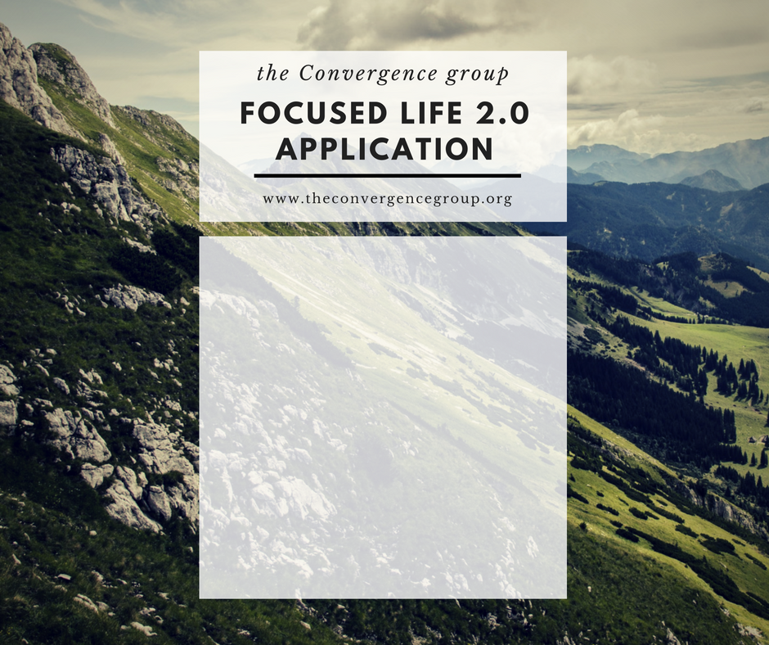

Spiritual Autobiography
Life and Leadership Lessons

Core Values

Purpose/ Mission Statements

Ultimate Contributions

Yearly Goals
Spiritual Autobiography
Take some time to work on your spiritual autobiography where you can pray and think through your life without distractions. Begin your autobiography with your birth and list in chronological order remembrances of the key people, experiences, circumstances, events, transitions, successes, failures, etc. that have contributed to who you are today.
General length: Depending on your age and variety of life experiences, your autobiography can be pretty brief or lengthy. Let me suggest the following general guidelines (you do not have to limit yourself to these suggested lengths if you want to write more). If your age is:
- 20 something – 3-5 pages
- 30 something – 6-8 pages
- 40 and older – 9 plus pages

The more time and depth you can give this, the more you will probably learn about yourself and God’s involvement in your life to date. Again, remember that this is a prayerful exercise. You will be depending upon God to lead you through this process. Some things that do not seem to make sense, or seem to be issues that you have dealt with may emerge in the process. That is O.K. Write them down and move on.

Spiritual Autobiography:

Life and Leadership Lessons

Before you start listing your life and leadership lessons, let’s review what is meant by processing, deep processing, process items, and transformation:

- Processing – providential events, people, circumstances, and events that God uses to assist in the development of character, values, skills, understanding, etc. for life and leadership effectiveness.
- Deep Processing – overwhelming circumstances that “force” us to go deeper in God than we ever have before resulting in deeper understanding of his love and how he uses us for his purposes.
- Process Items – specific situations designed by God to assist us in his transformation process.
- Transformation – the process of changing one’s attitudes (heart), perception (mind), and behavior to reflect the likeness of Christ.

List significant incidents from your Time-Line and process items (and/or lessons) that God was teaching you.

Life and Leadership Lessons:

Core Values

Each of us has perceived, proclaimed, and real values. Our real values are our core values. How we treat people, how we spend our money, what we do in our spare time – these behaviors reflect our true values.

Track 1: Biblical Core Values - What has God taught you from his Word?
Track 2: Core Values – What has God taught me from life and leadership experiences?
Biblical Core Values/Core Values
1.
2.
3.
4.
5.
6.
7.
8.

Purpose and Mission Statements

Let’s take a look at what is meant by purpose and mission. They are not the same thing, but they are both important and go together:

- Purpose (“being”) – sense of identity or calling based on Biblical core values or core values

- Mission (“doing”) – your best understanding to date of what you believe God would have you do with your life

Purpose Statement:

Mission Statement:

Ultimate Contributions

Ultimate contributions are “a lasting legacy of a Christian worker for which he or she is remembered and which furthers the cause of [Christ]…” (Clinton’s Biblical Leadership Commentary, p. 404-405). A lasting legacy (ibid, p. 512) is described in terms of the following general categories of influence:

- Character - setting standards for life and leadership.
- Ministry [Leadership] - impacting lives through evangelism and/or disciple-making (mentoring).
- Catalytic - serving as a change agent who helps make the world better.
- Organizational - leaving behind an organization, institution, or movement that will impact society in kingdom-advancing ways.
- Ideation - discovering, developing, describing, communicating, or promoting ideas that help others come to or grow in faith.

Clinton has identified 12 ultimate contributions in his research that relate to one or more of these legacy characteristics (ibid, p. 512).

Ultimate Contributions:

Yearly Goals

Write down your best sense of where you will be in the future:

25 years from now (for twenty and thirty something folks):

10 years from now (for twenty, thirty, and forty something folks):

5 years from now (for everybody):

SMART Goals - A basic set of guidelines for establishing effective goals is the SMART approach. SMART is the acronym for goals that are:

- Specific
- Measurable
- Achievable
- Relevant (or related to vision)
- Timeframe

One Year Strategic Plan of Action (using SMART goals):

